CellProfiler segmentation + classical features

Accuracy: 80.58252427184466%

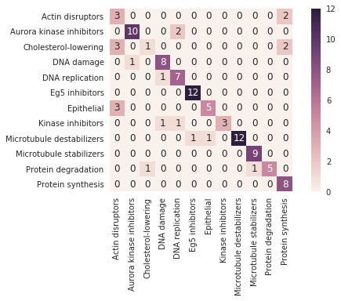

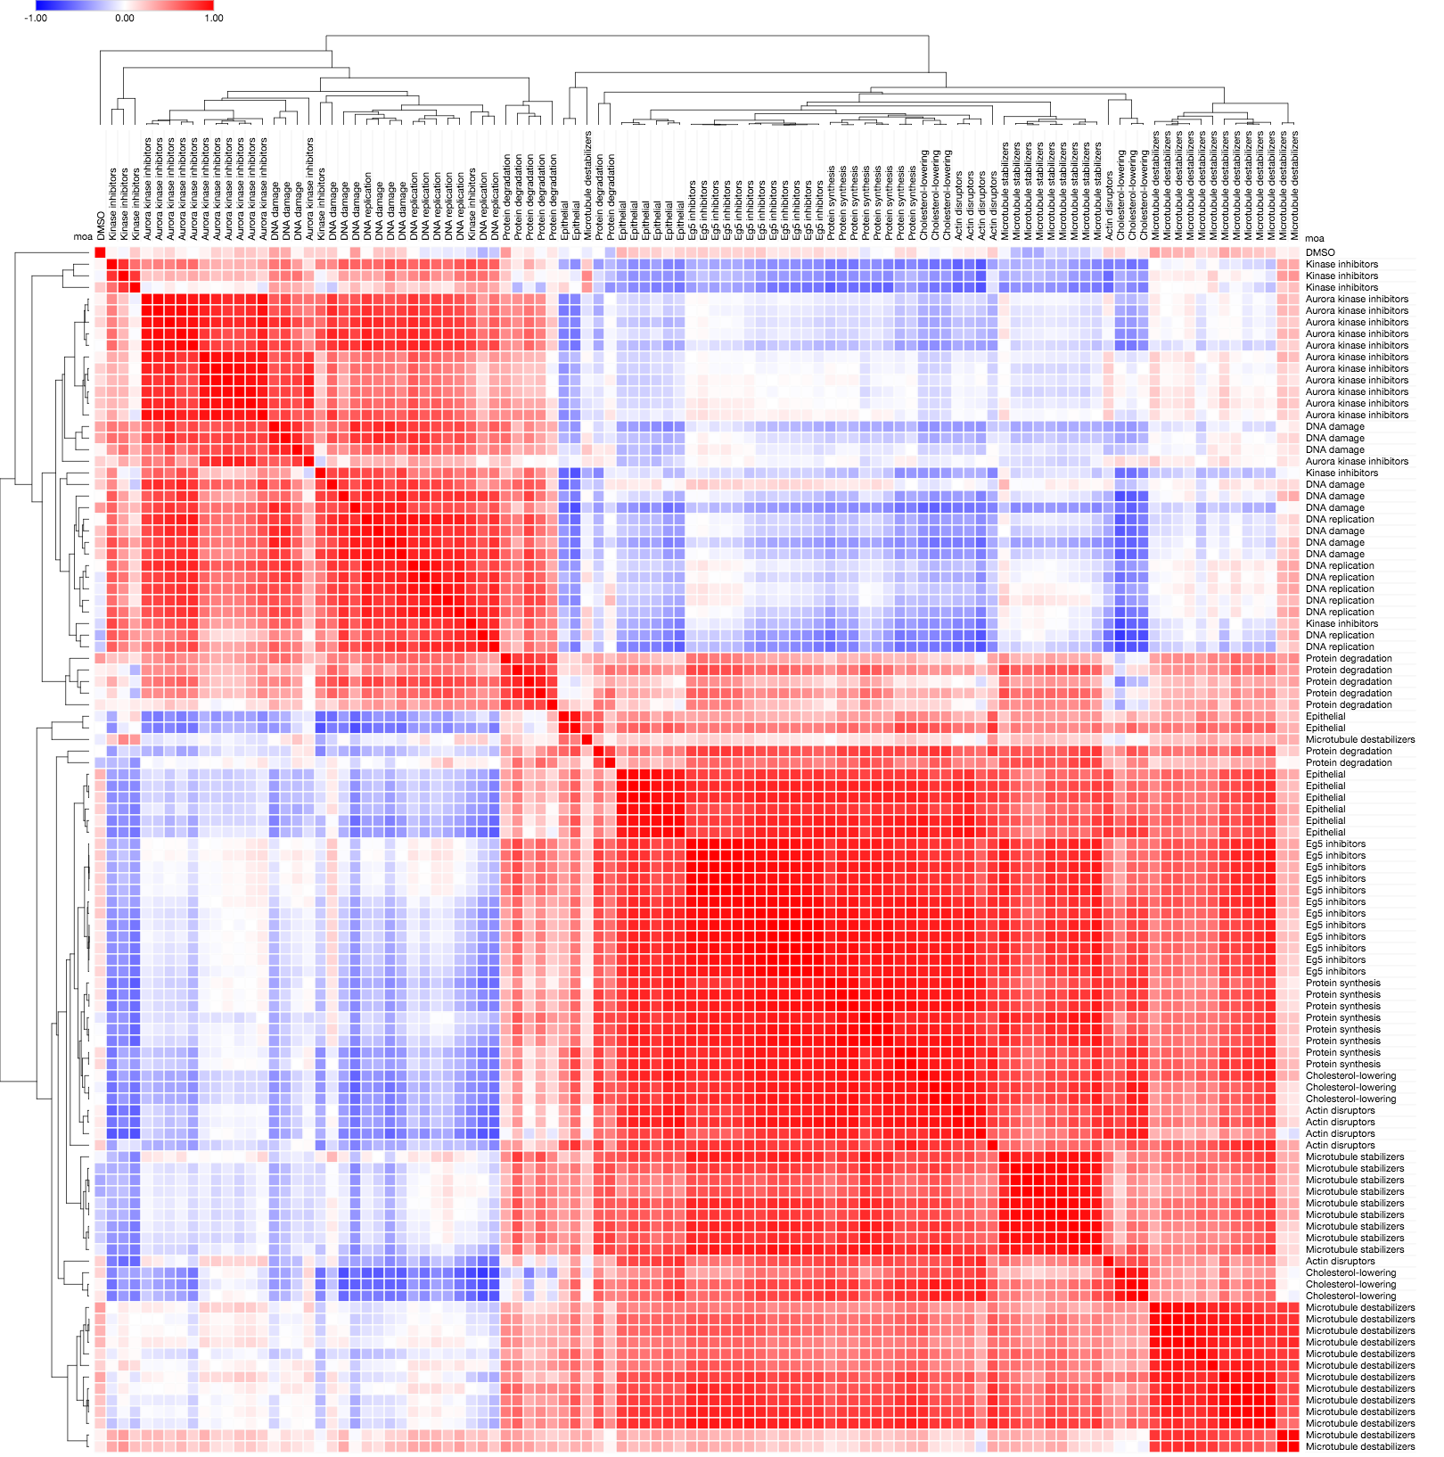

CNN segmentation + classical features

Accuracy: 84.46601941747572%

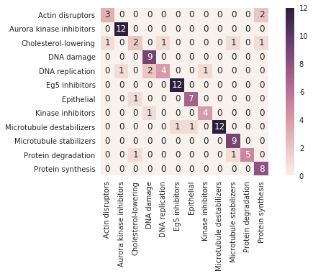

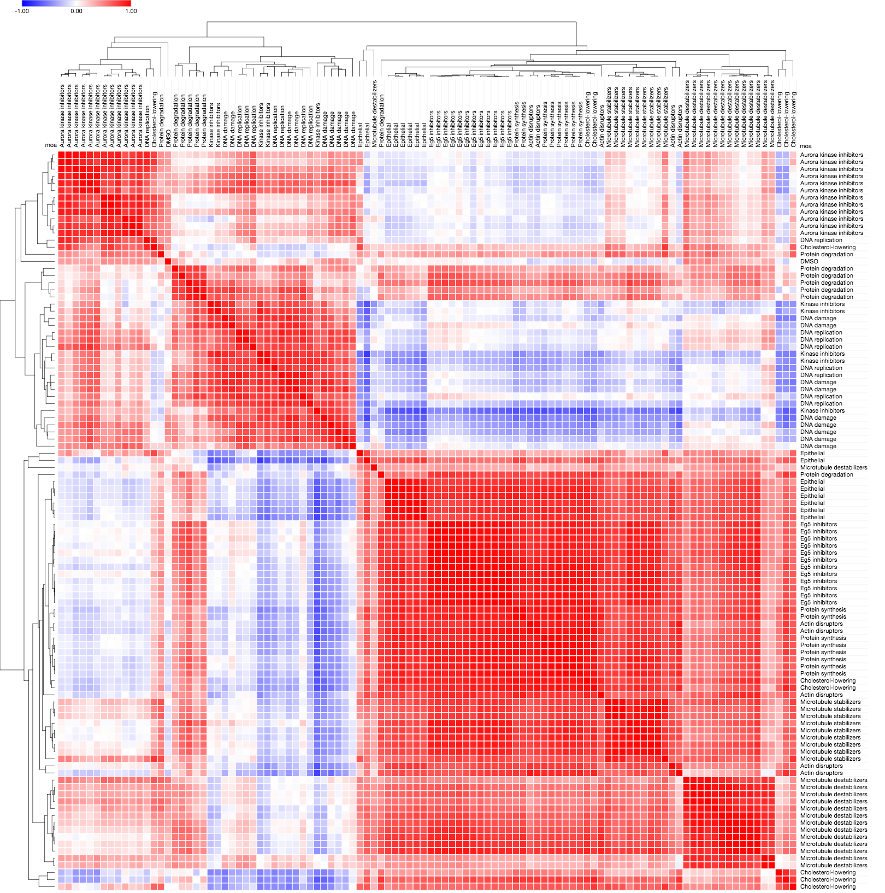

CellProfiler segmentation + convolutional features

Accuracy: 90.29126213592234%

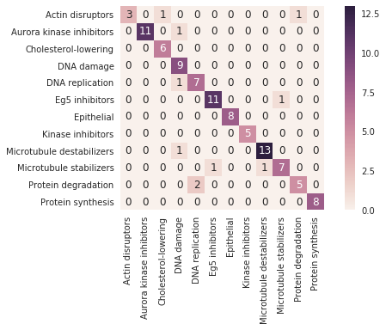

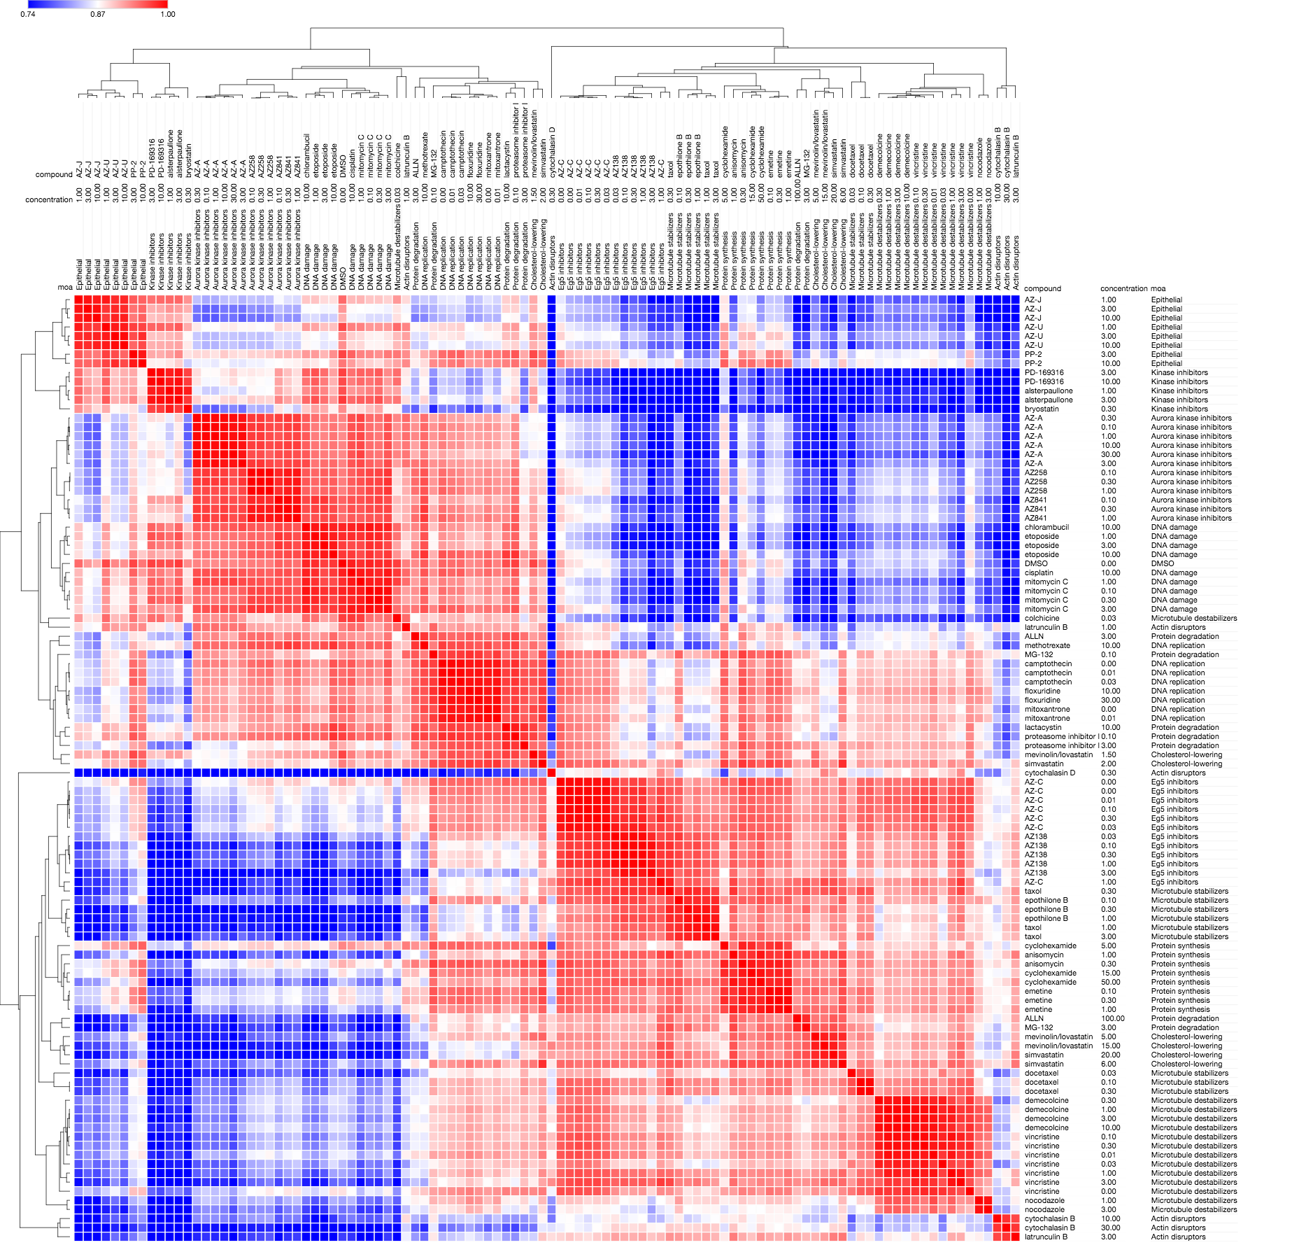

CNN segmentation + convolutional features

Accuracy: 87.37864077669903%

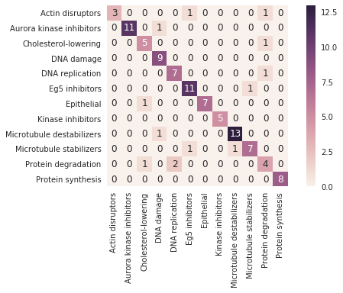

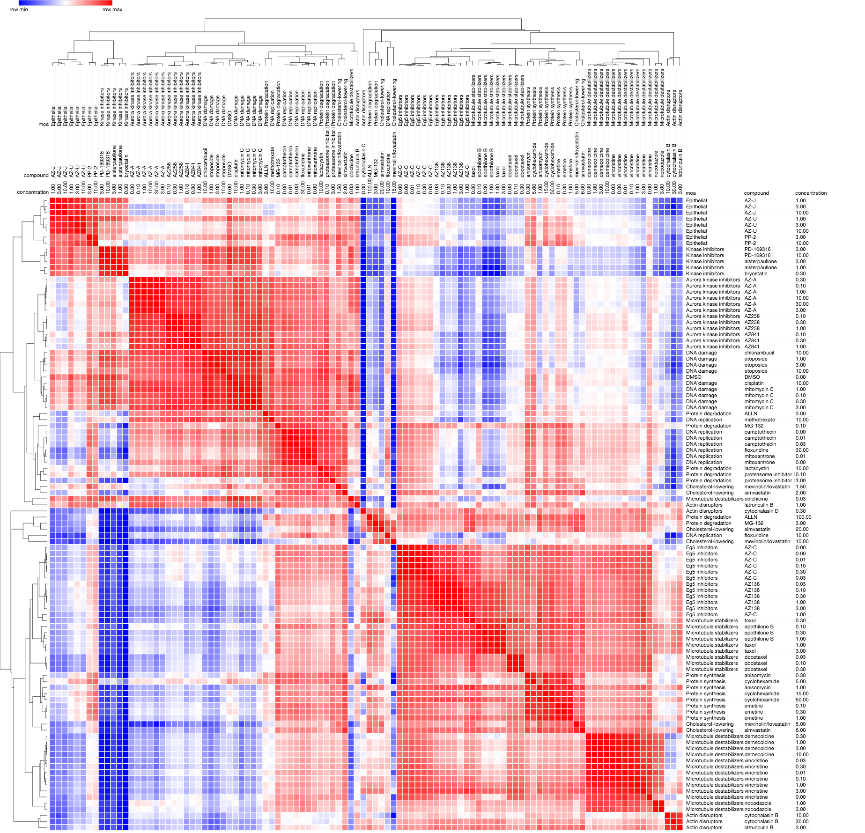

CellProfiler segmentation + convolutional features + whitening

Accuracy: 94.1747572815534%

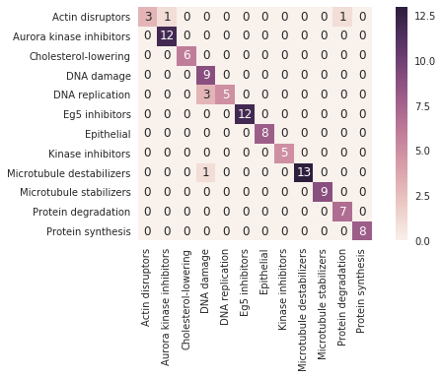

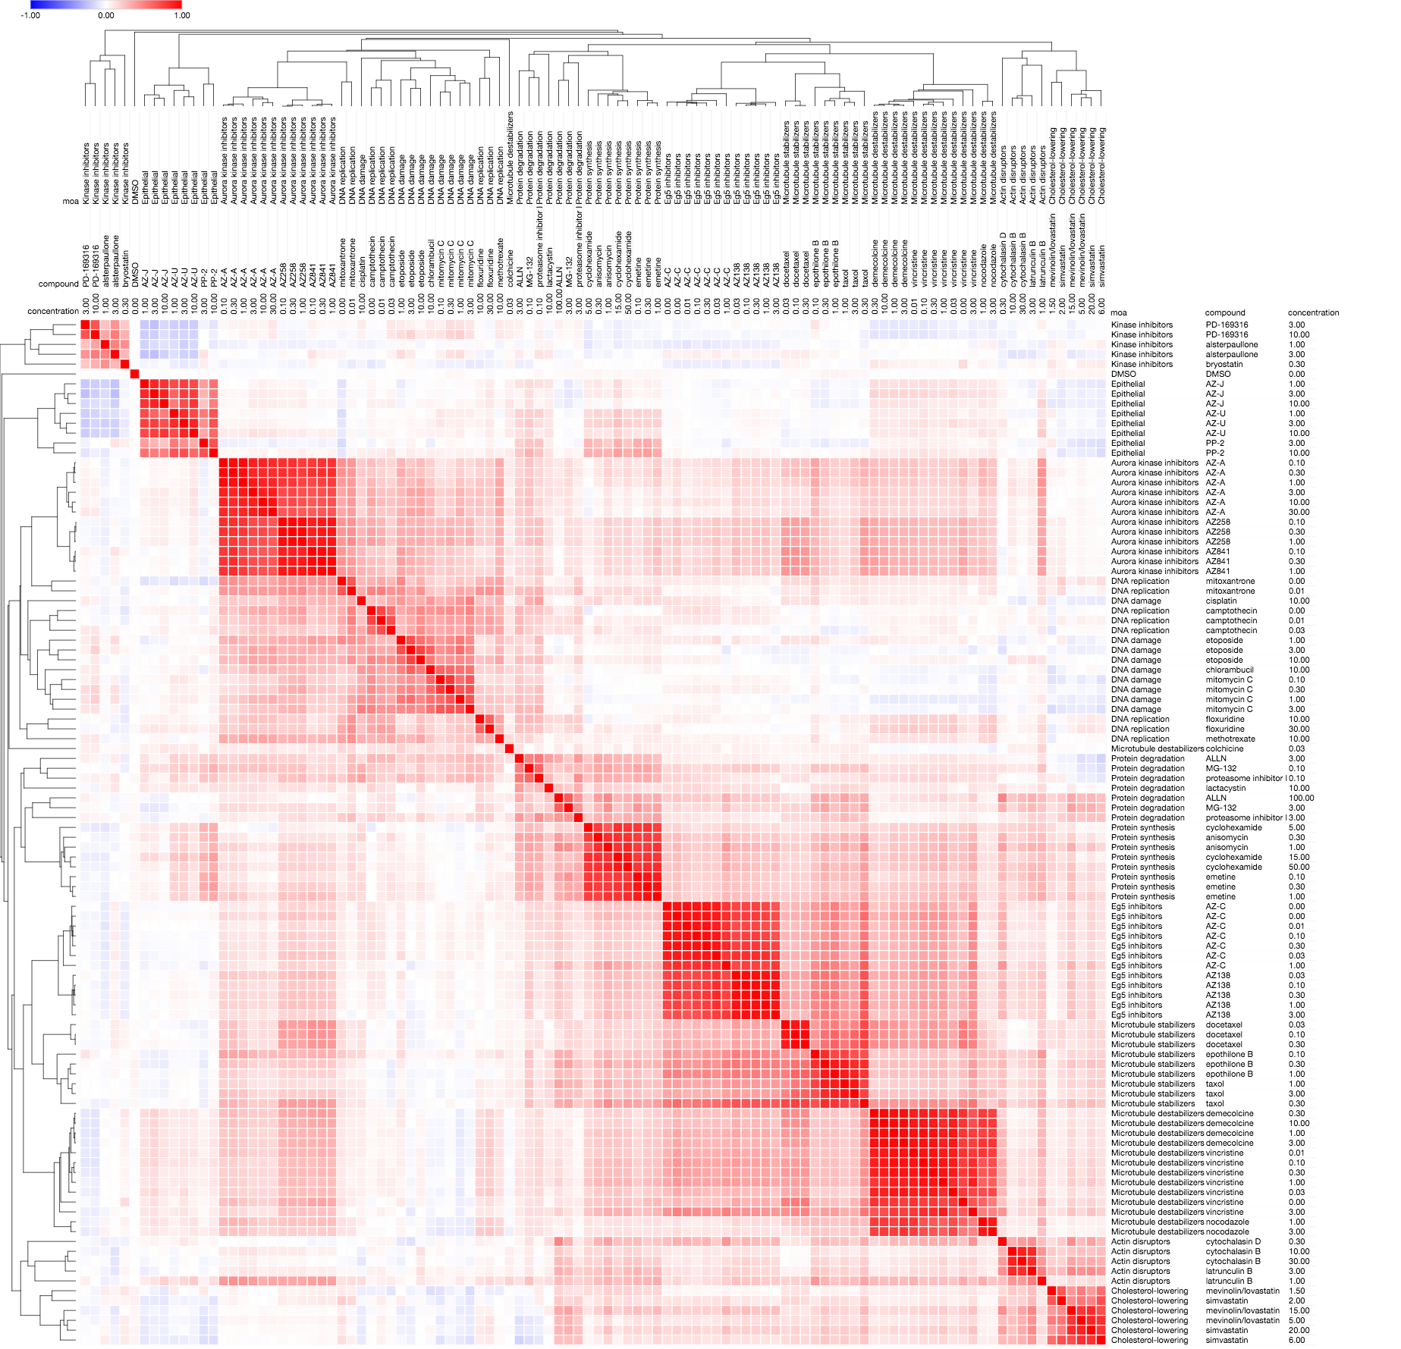

CellProfiler segmentation + convolutional features + double whitening

Accuracy: 94.1747572815534%



